IOT Based Fire Department Alerting System

Fires are one of the most widespread cause of deaths by accident. Instant alerting to the fire department is necessary to ensure immediate action. Every minute can save many lives in such situations. So here we propose an IOT based automatic fire department alerting system that instantly and automatically alerts the fire department and informs about the situation so that immediate action can be taken. The system uses Fire sensor along with PIR sensor to efficiently detect fires and alert fire department over IOT. We use an arduino uno in order to check if a sensor is triggered. Then it reconfirms if it really is a fire outbreak using temperature sensors in order to confirm of fire outbreak. The system now uses a wifi connection to access IOT server and transmit data about this incident over internet. We here use IOTGecko platform to develop the web based IOT interface. As soon as IOTGecko system receives the sensor data it checks the device id data was sent from and displays device id(which will be named after area/flat id). The system now displays the fire incident with alarm buzzer in the fire department over internet so that the fire department personnel are alerted about the incident to take necessary action.

Block Diagram :

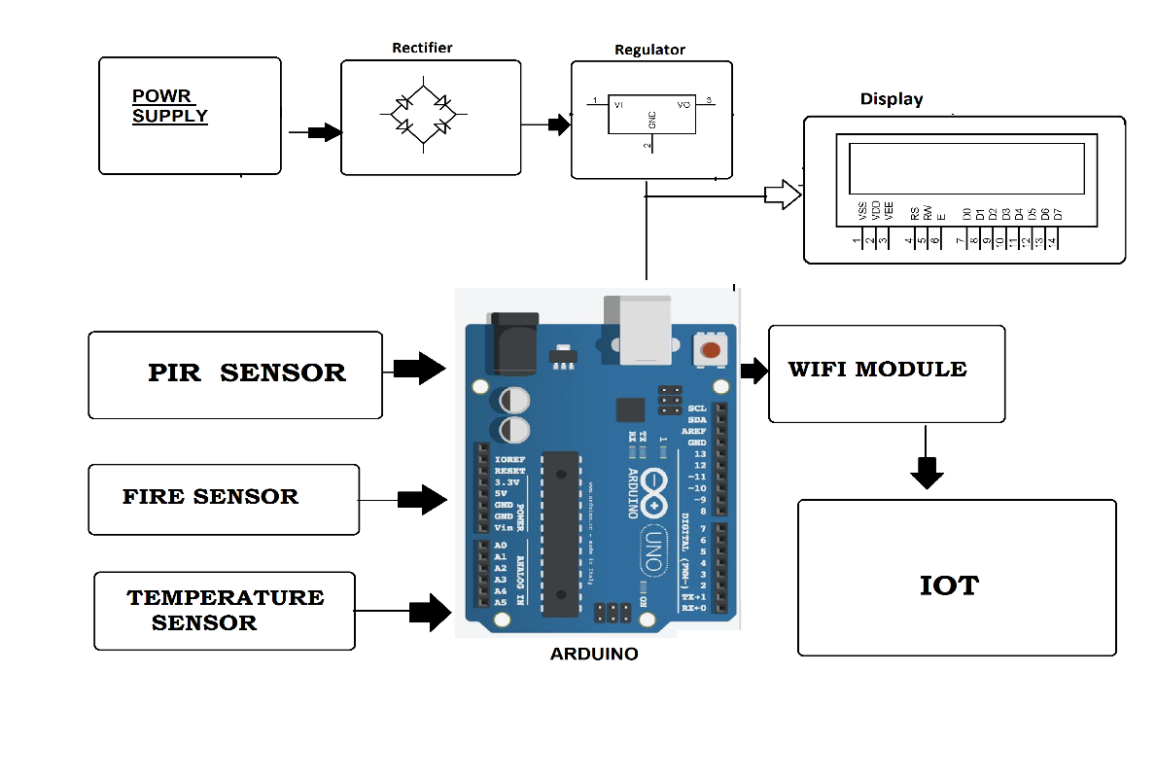

Hardware Specifications :
- Rectifier
- Regulator
- Power Supply
- LCD Display
- PIR Sensor
- Arduino Uno
- Wifi Module

Software Specifications :
- Arduino Compiler
- MC Programming Language: C

